xi Mysql

**1) To Create a database.**

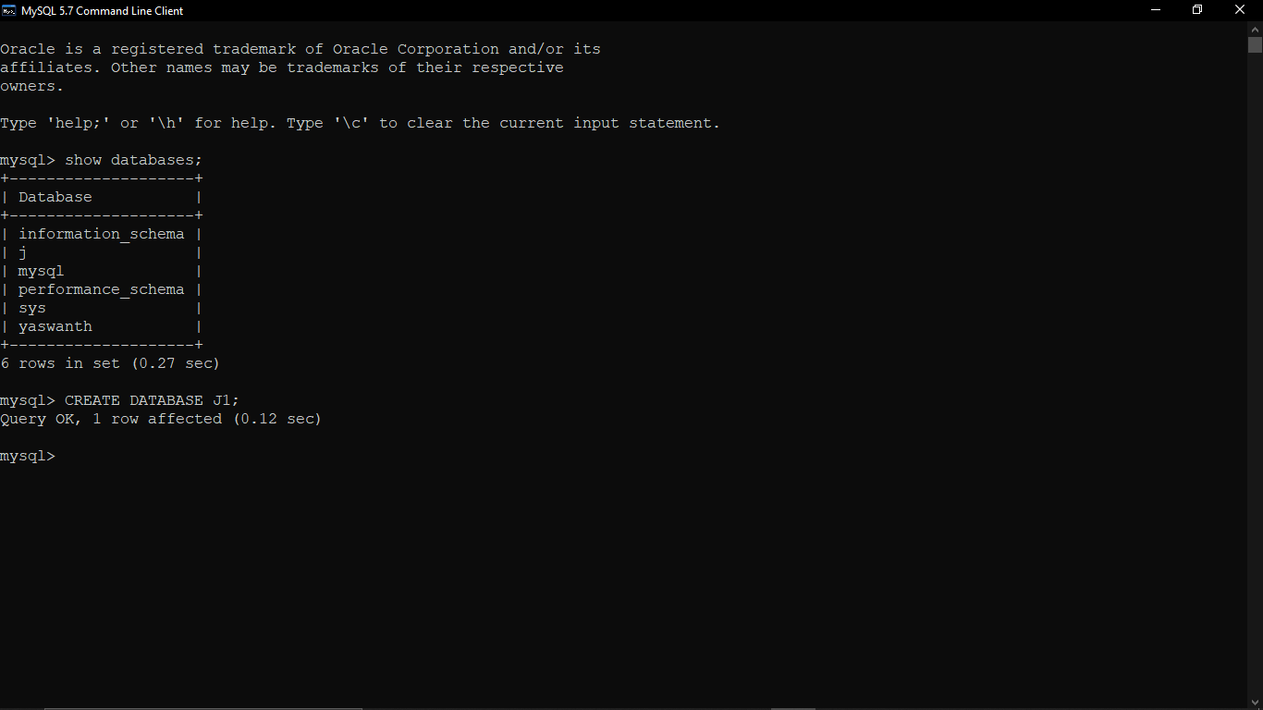

**2) To crate student table with the student id, class, section, gender, name, dob, and marks as attributes where the student id is the primary key.**

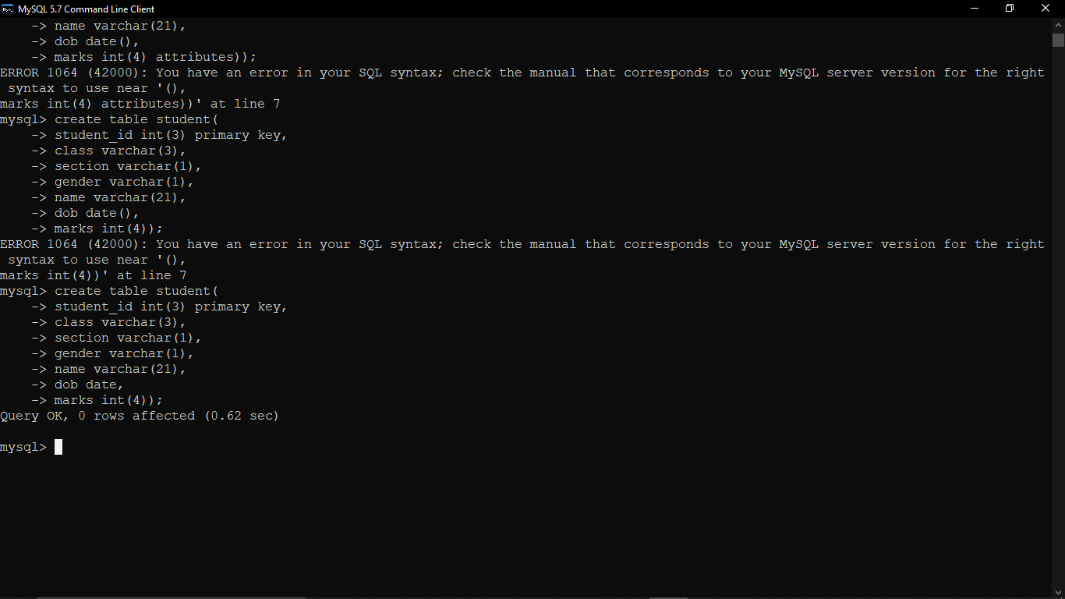

**3) To insert the details of at least 10 student in the above table.**

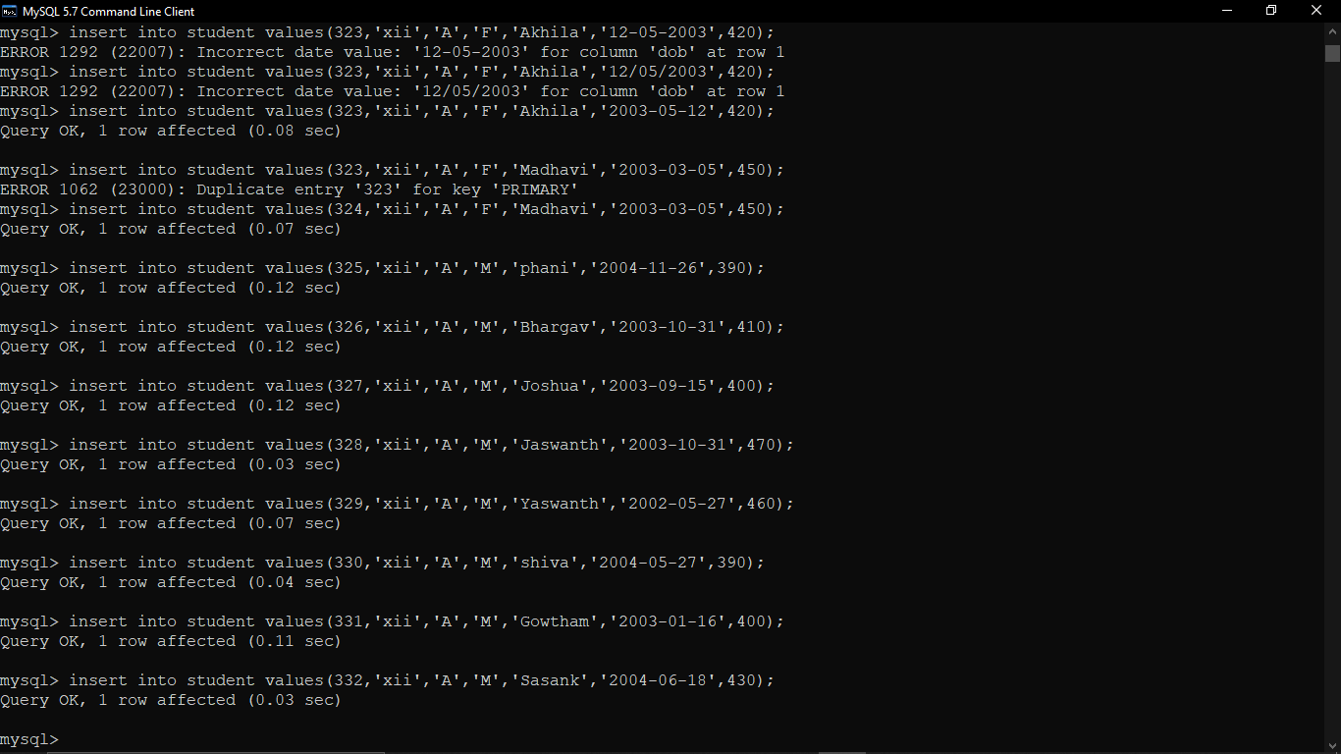



















**4) To delete the details of a particular student in the above table.**

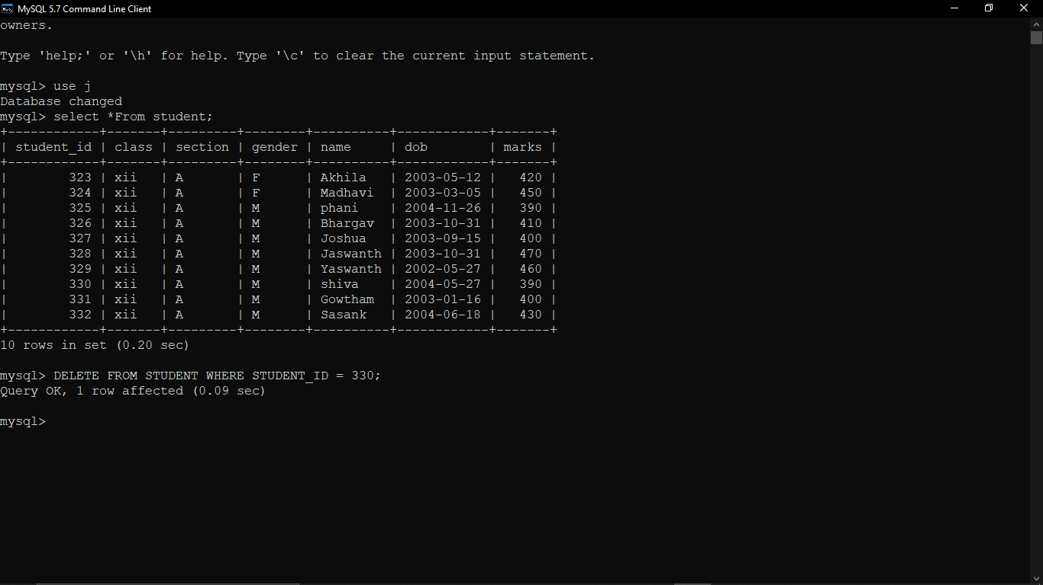

**5) To increase marks by 5% for those students who have Rno more than 20.**

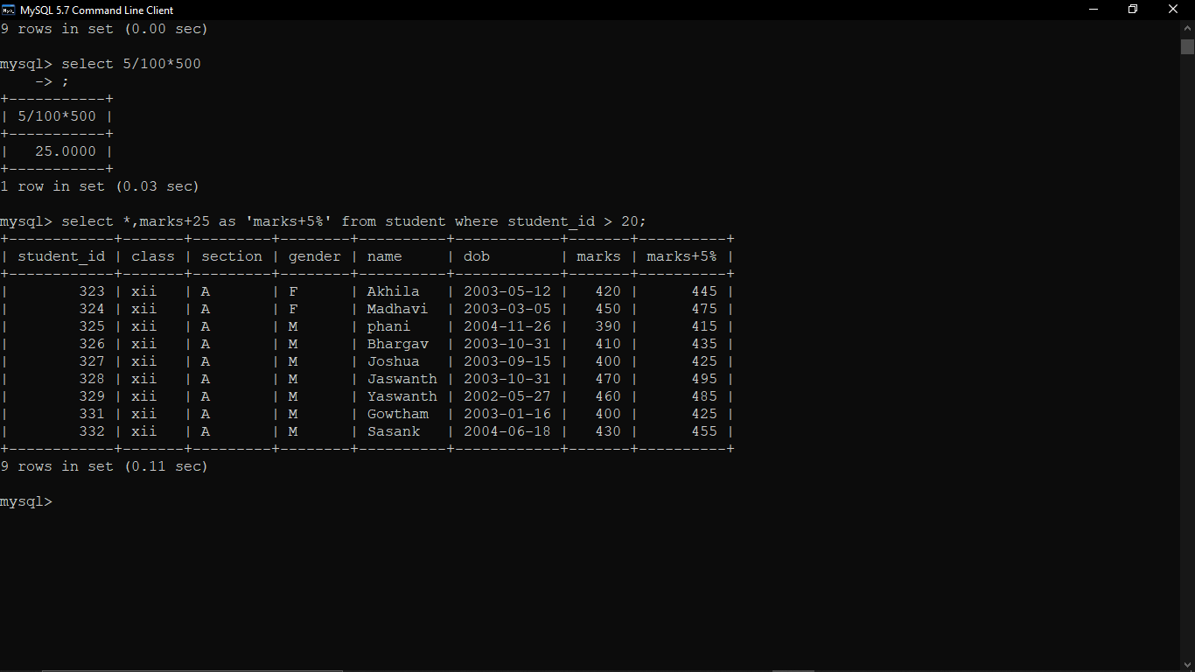

**6) To display the entire content of table.**

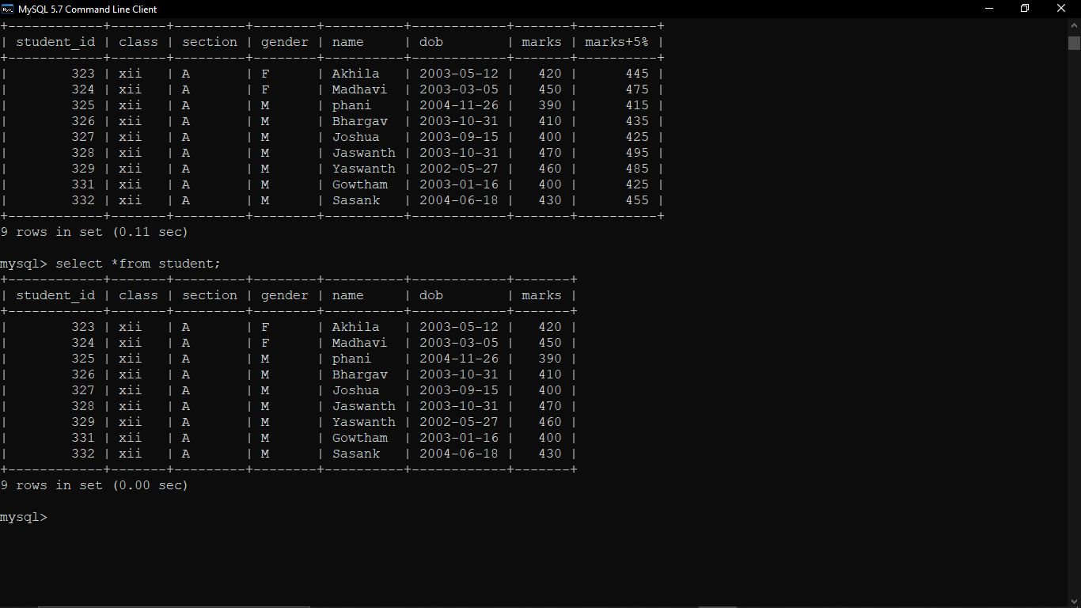

**7)To display Rno , Name and marks of those students who are scoring marks more than 50.**

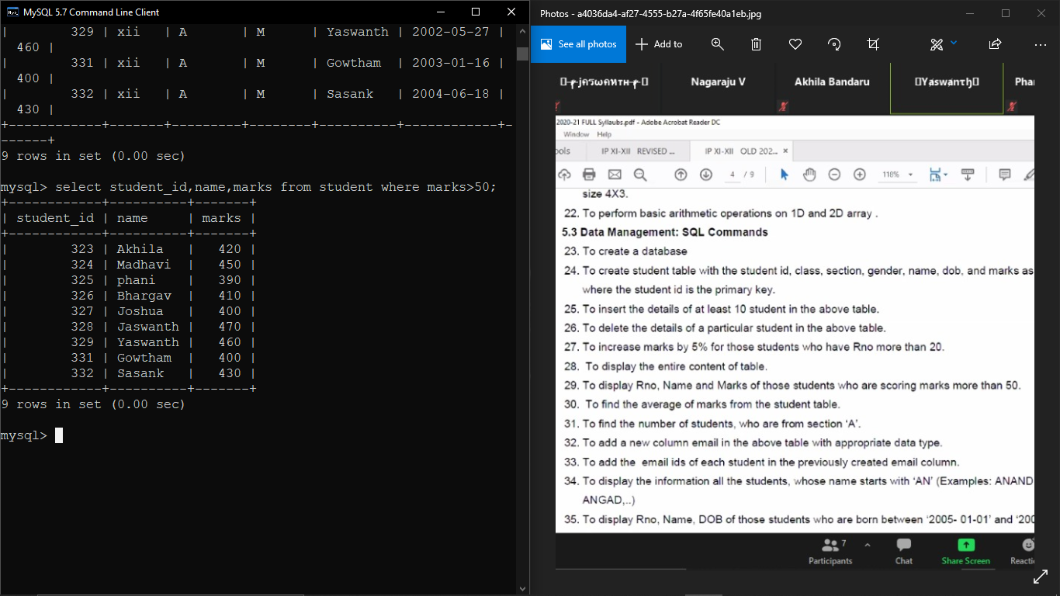

**8) To find the average of marks from the student table.**

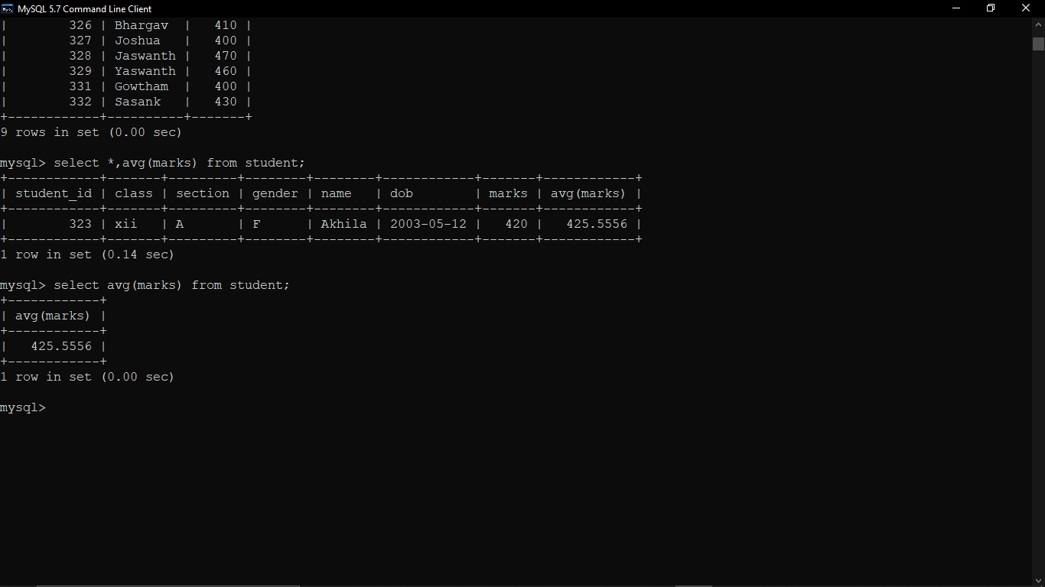

**9) To find the number of students, who are from section ‘A’.**

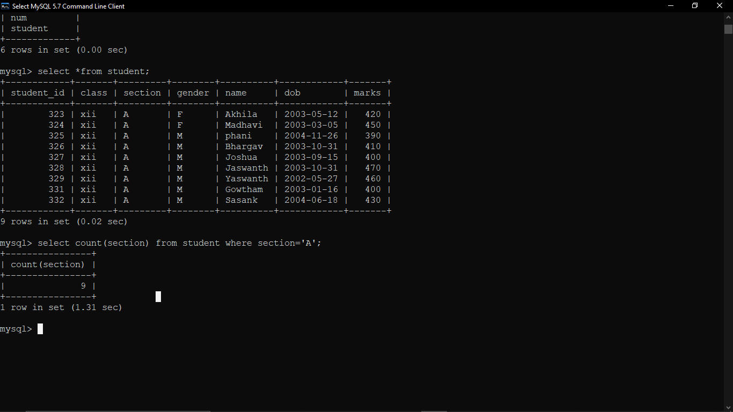

**10) To add a new column email in the above table with appropriate data type.**

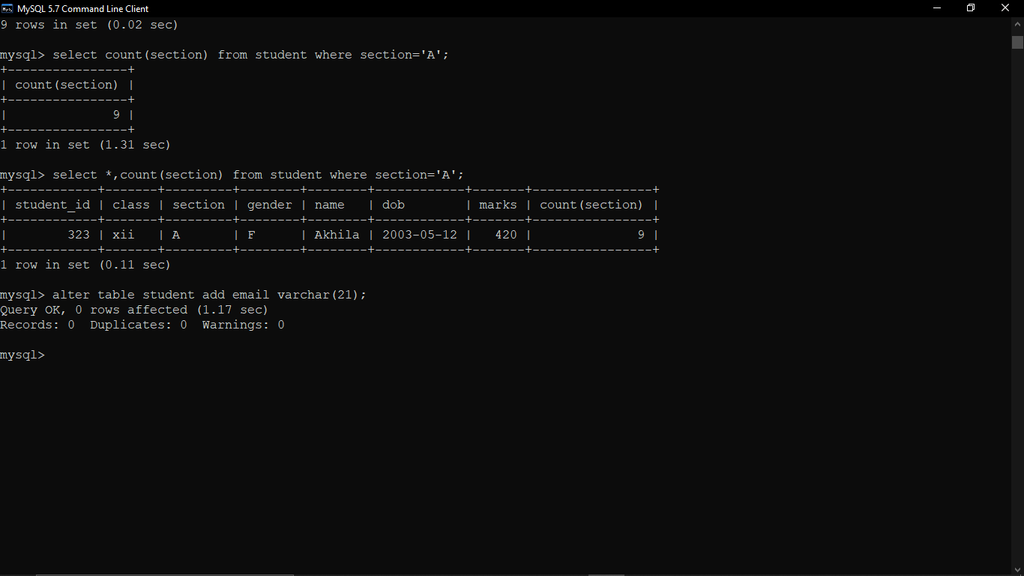

**11) To add the email ids of each student in the previously created email column.**

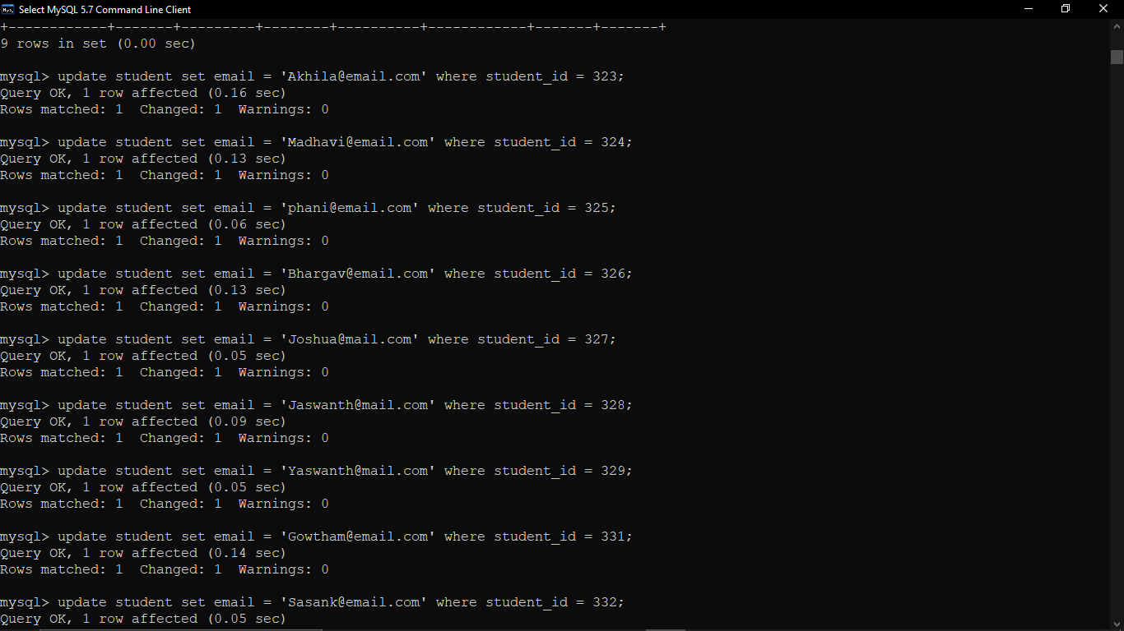

**12) To display the information all the student, whose name starts with ‘AN’(Examples:ANAND,ANGAD,…)**

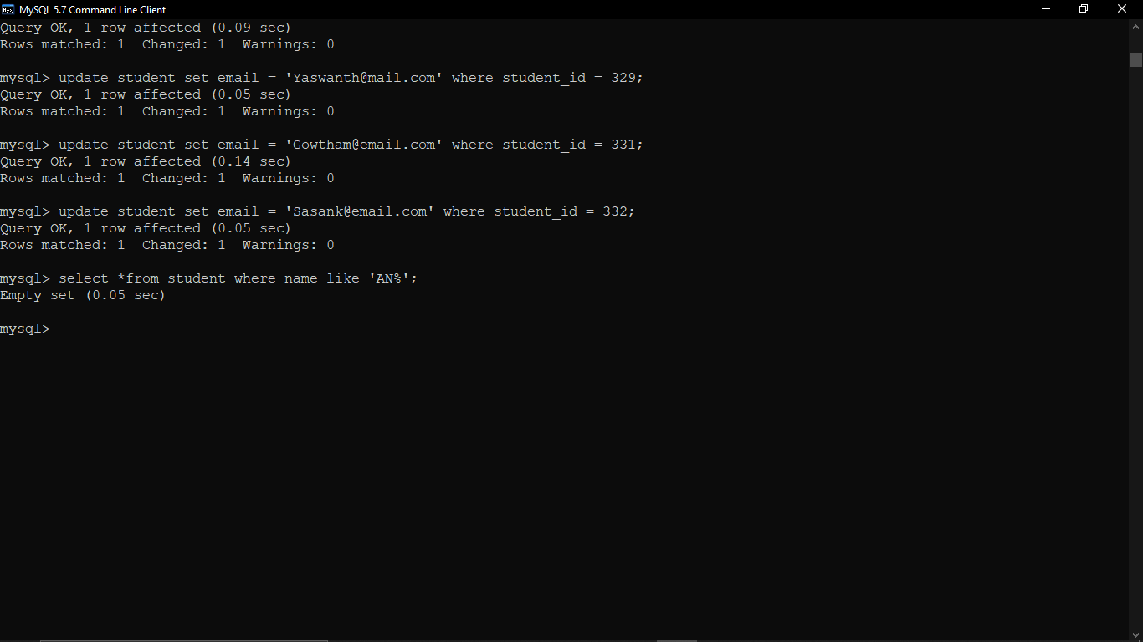

**13) To display Rno,Name,DOB of those students who are born between ‘2005-01-01’ and ‘2005-12-31.**

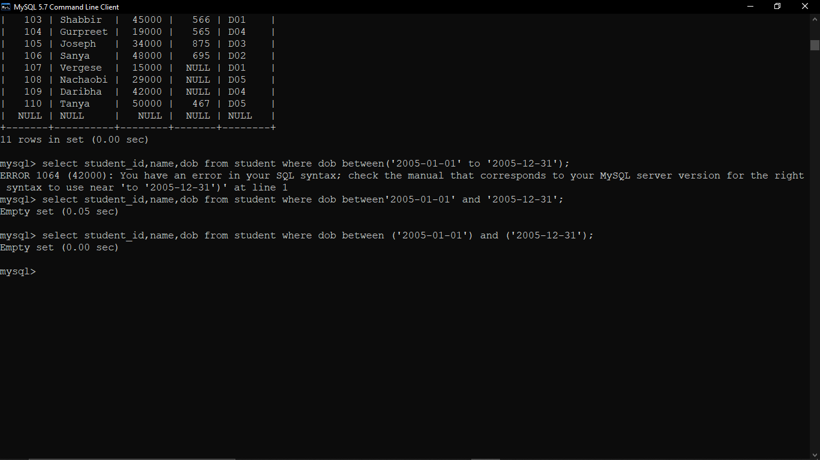

**14) To display Rno,Name,DOB,Marks,Email of male student in ascending order of their names.**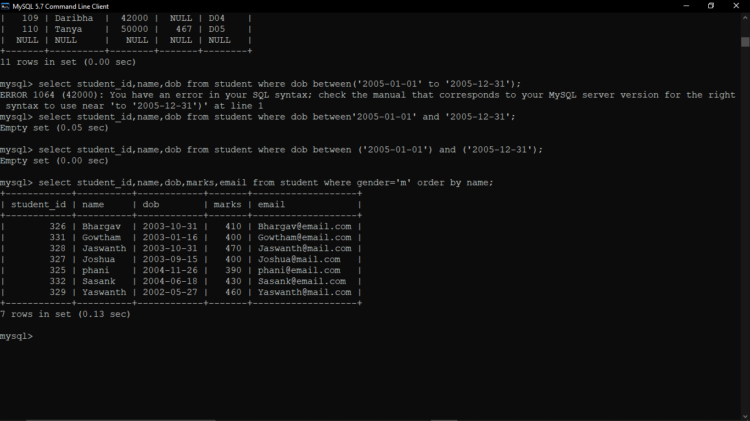

**15) To display Rno, Gender, Name, DOB, Marks, Email in descending order of their marks.**

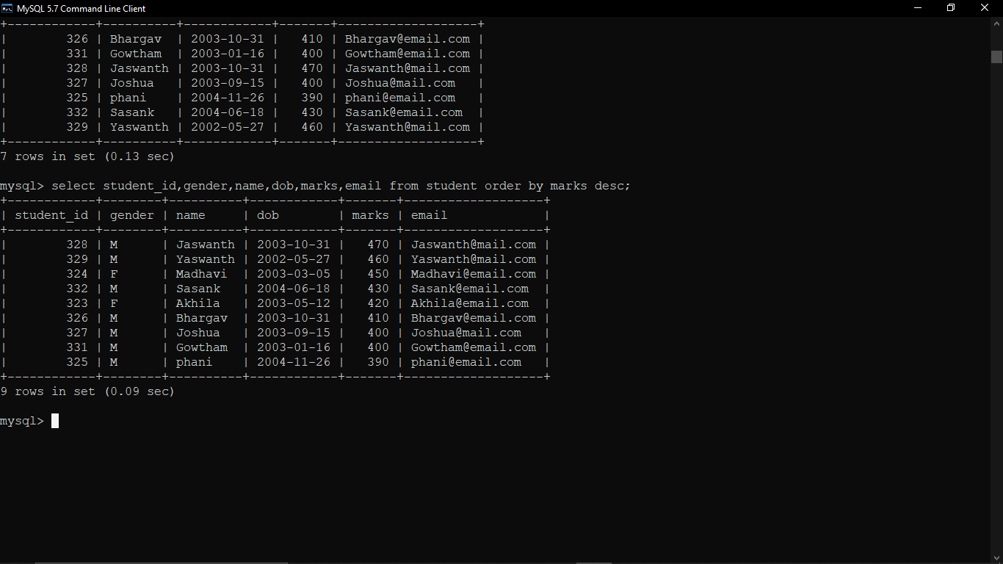

**16)To find the max marks and min marks obtained by students.**

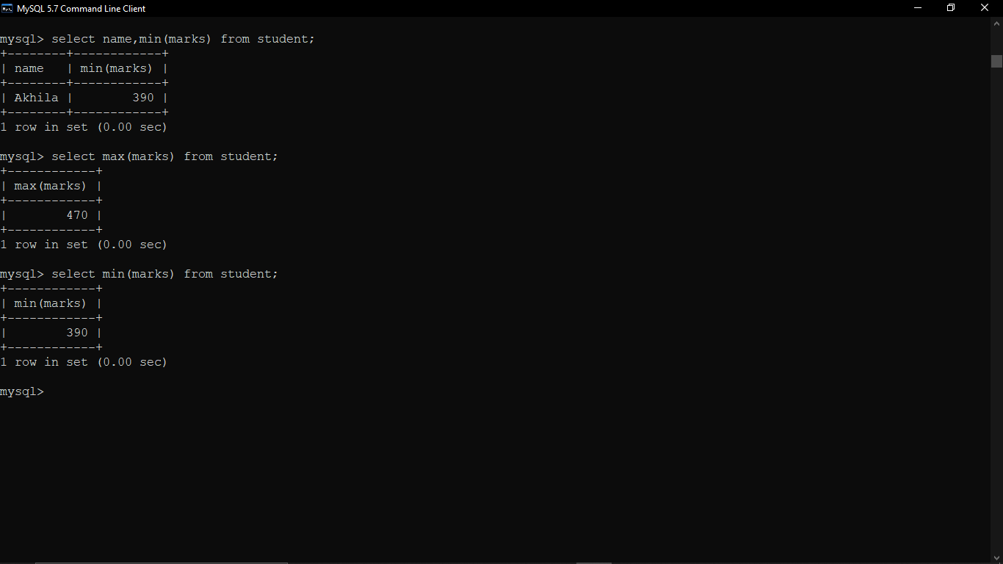

**17) To display the unique section available in the table.**

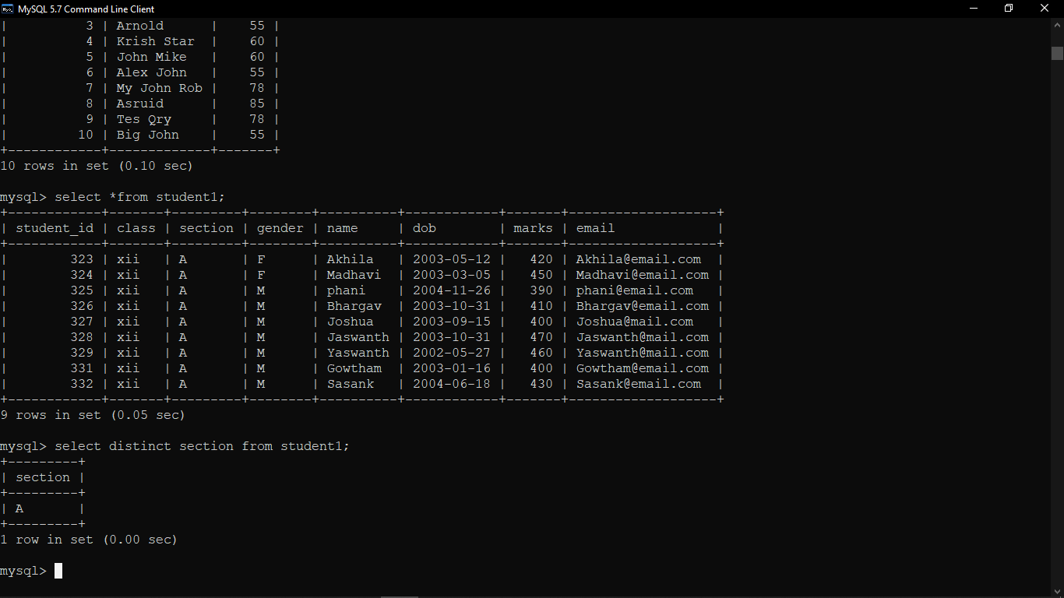

Xii Mysql

1. **Create a student table with the student_id, name, and marks as attributes where the student id is primary key.**

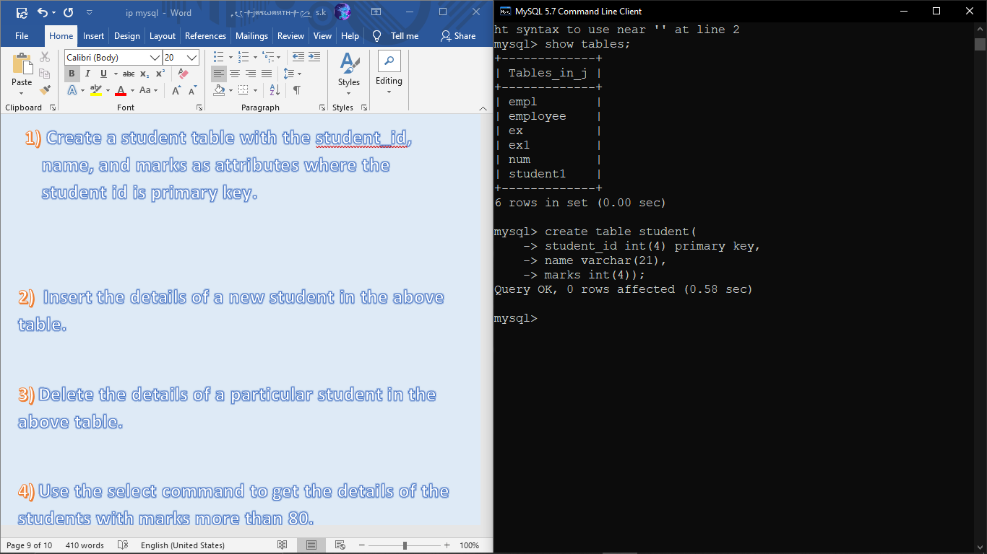

**2) Insert the details of a new student in the above table.**

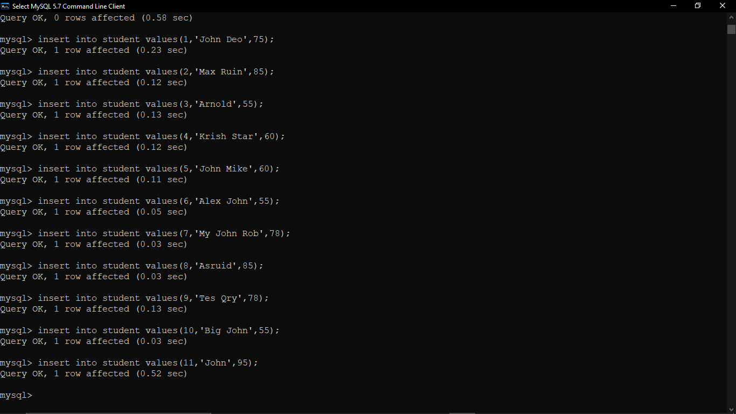

**3) Delete the details of a particular student in the above table.**

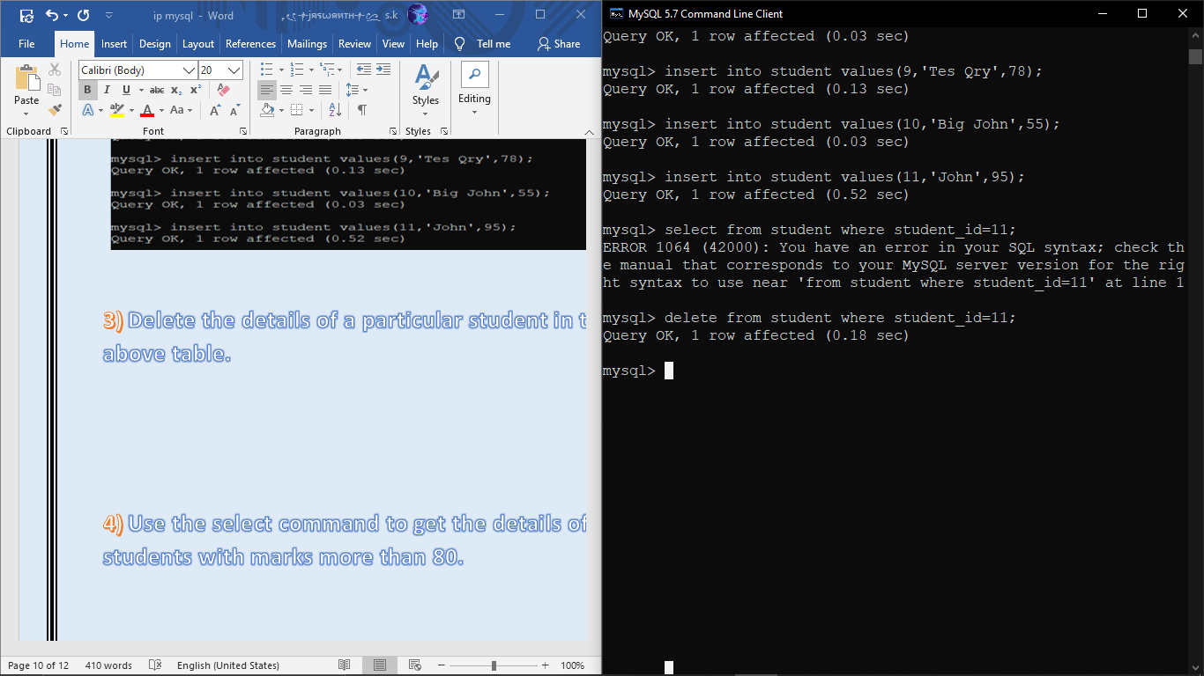

**4) Use the select command to get the details of the students with marks more than 80.**

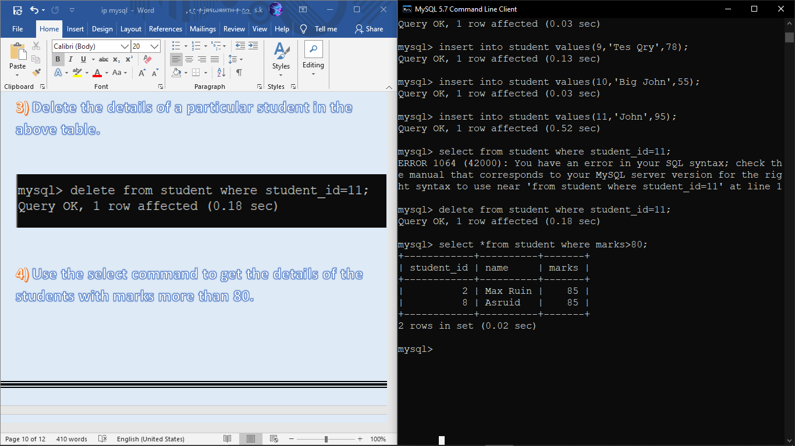

**5) Create a new table (order ID, customer name, and order Date) by joining two tables (order ID, customer ID, and order Date) and (customer ID, customer Name, contact Name, country).**

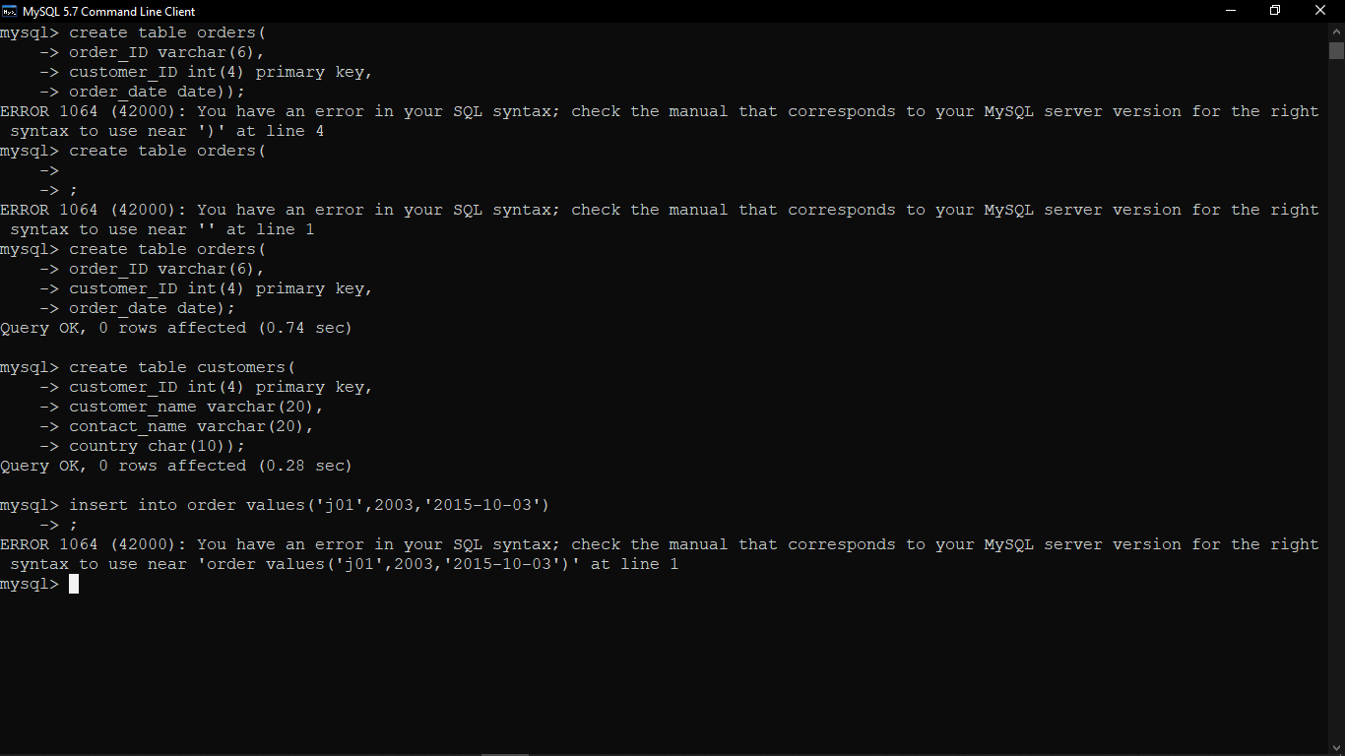

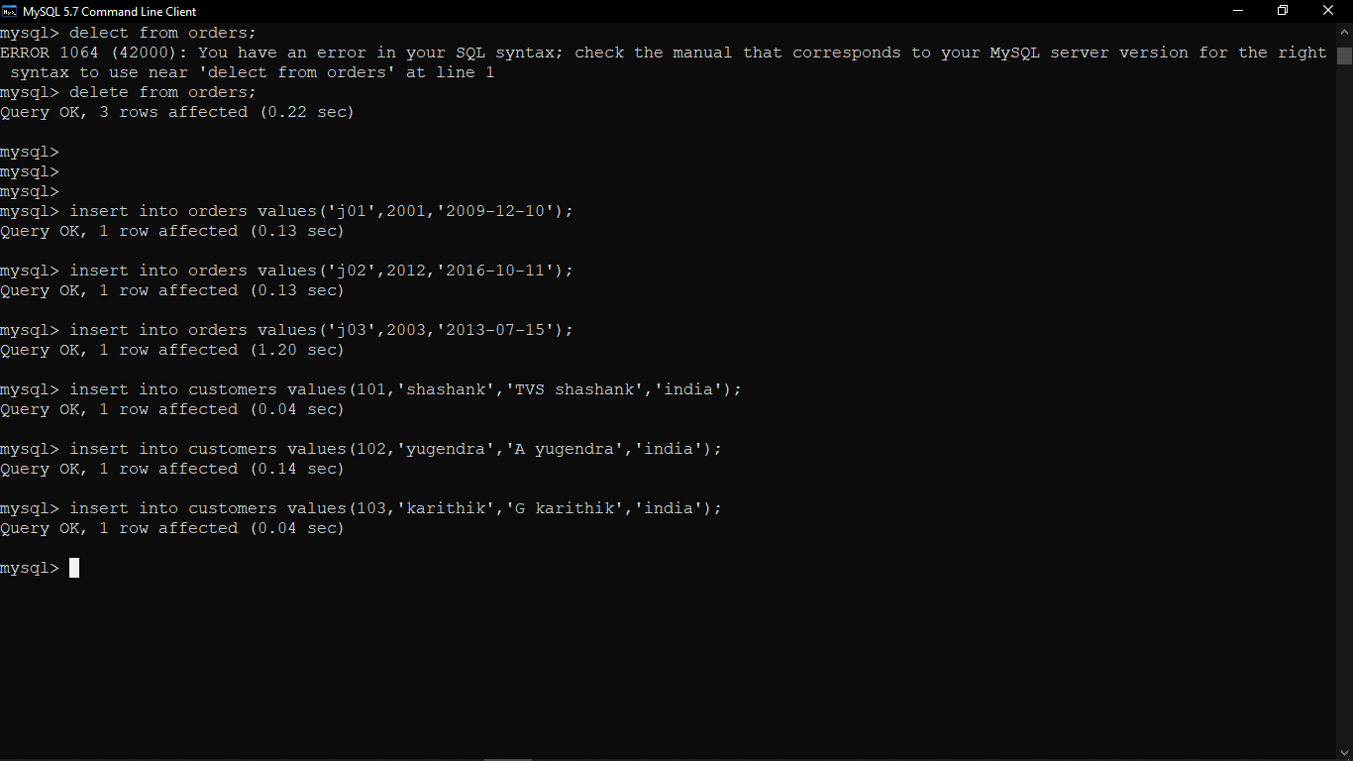

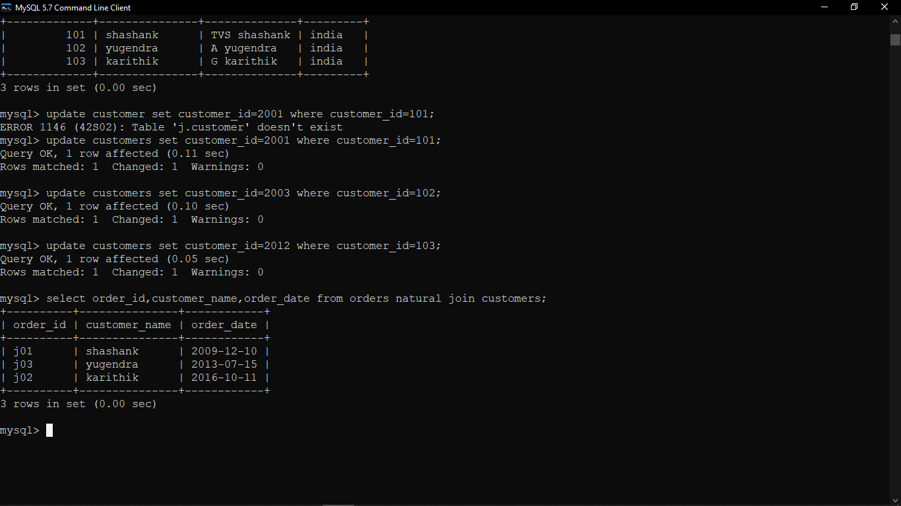

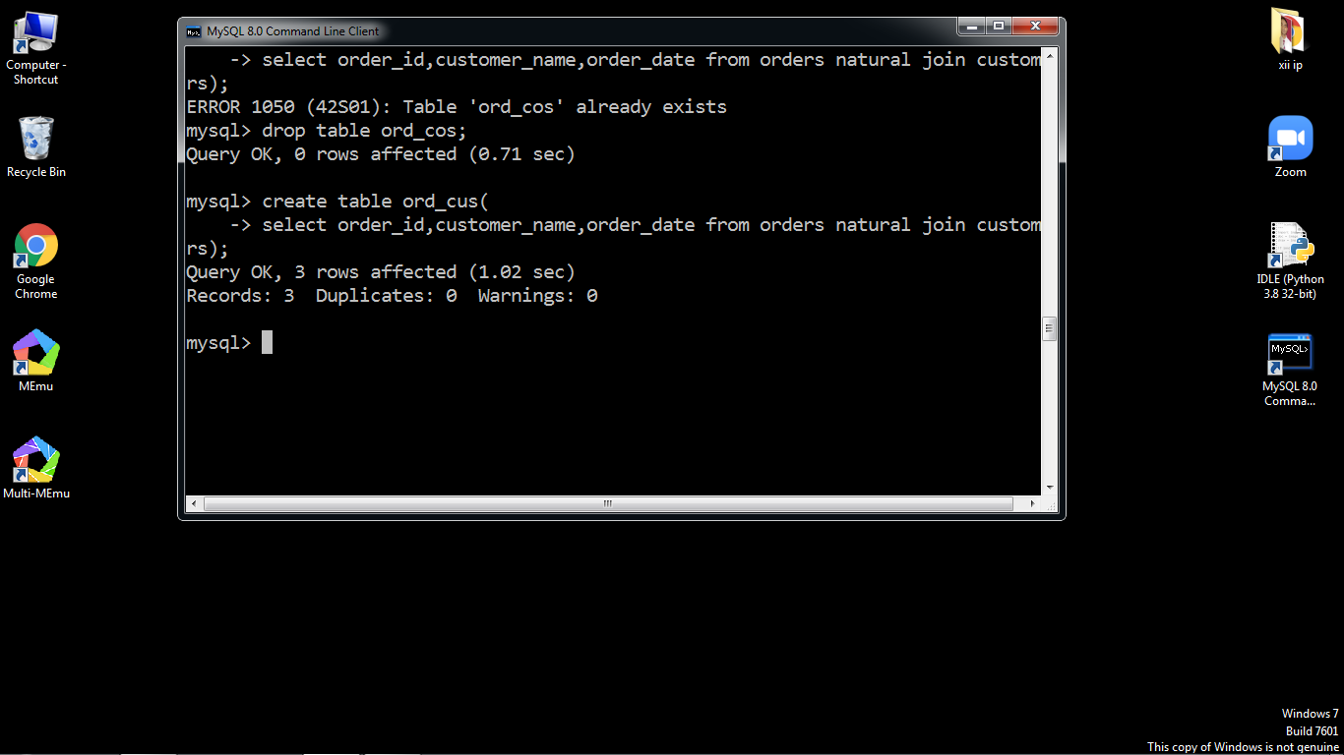

**6) Create a foreign key in one of the two tables mentioned above.**

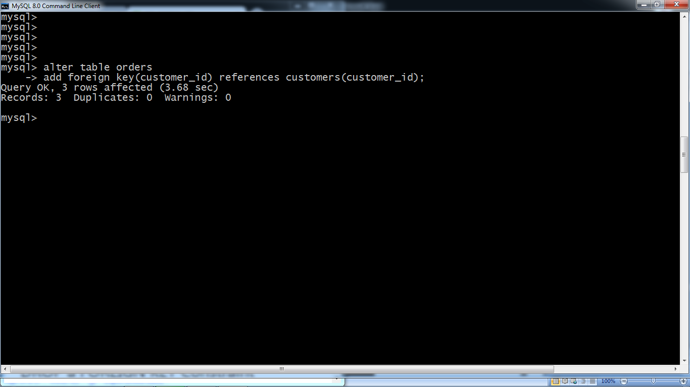

**7) Find the min, max, sum, and average of the marks in a student marks table.**

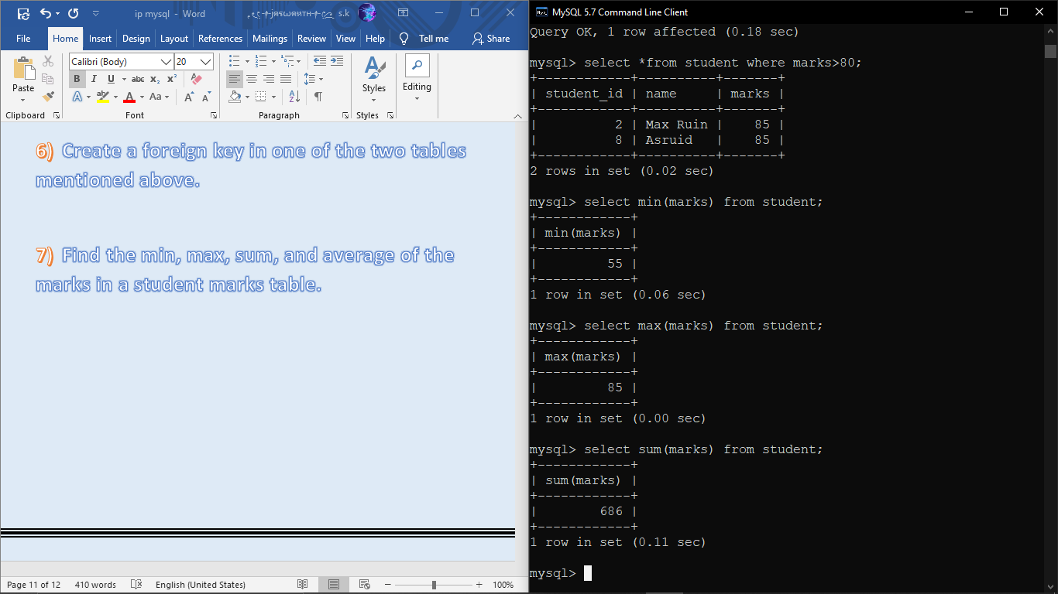

**8) Find the total number of customers from each country in the table (customer ID, customer Name, country) using group by.**

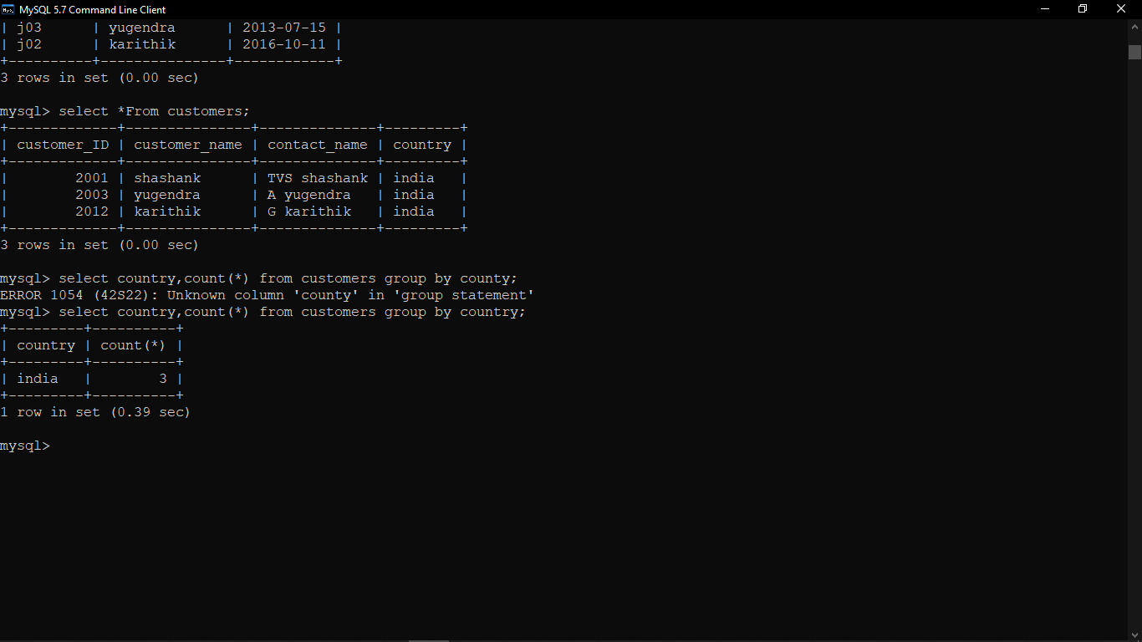

**9)Create a new table (name, date of birth) by joining two tables (student id, name) and (student id, date of birth).**

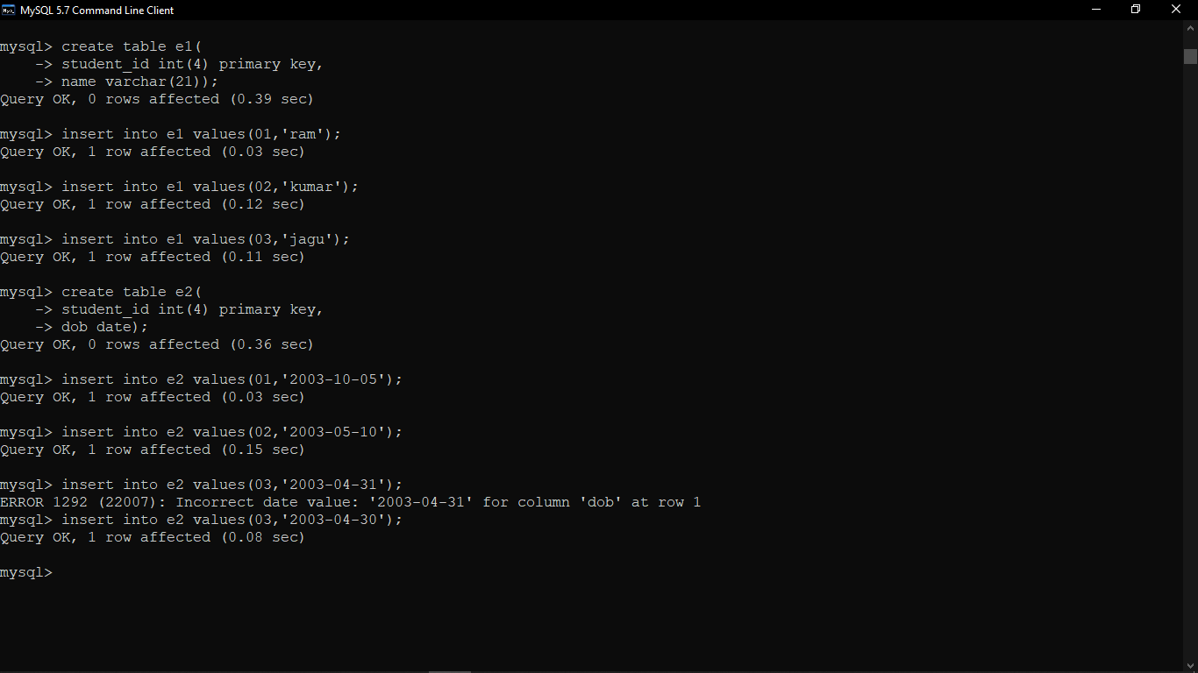

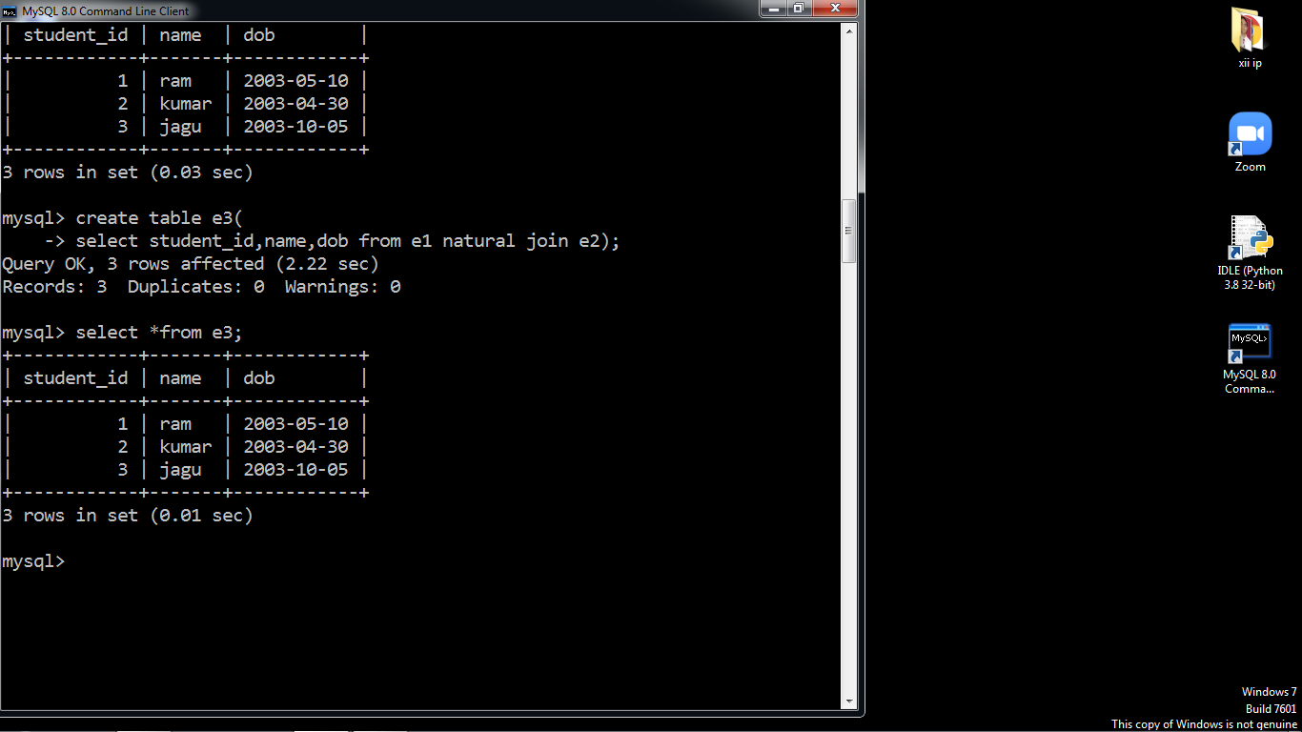

**10) Write a SQL query to order the (student ID, marks) table in descending order of the marks.**

